AGENT SIMULATION AS A TOOL FOR ASSESSING THE EFFICIENCY OF DISTANCE LEARNING IN IT EDUCATION

Natalia Petrenko,
Department of Information Technologies
Zaporizhzhya Institute of Economics and Information Technologies
Zaporizhzhia, Ukraine

Abstract — The paper presents an analysis of modern approaches to evaluating the effectiveness of modern educational systems and technologies and proposes an agent model for studying interaction and evaluating the effectiveness of actors in such systems. The analysis showed the presence of problems related to the complexity of educational systems, the emergence of new types of network structures, and the emergence of new requirements for the effectiveness of education. The developed agent model takes into account new types of interaction between participants of the higher education system - not only between the teacher and students, but also between elements of educational content and between students...

Keywords— Agent modeling, Distance learning, Effectiveness of IT education.

- INTRODUCTION

The rapid development of information and communication technologies in the world in recent decades has caused important changes in all spheres of human life and activity. The processes associated with science and education have moved to the forefront of these changes. Traditional educational institutions must respond very quickly to new challenges. The growth of globalization, the rapid obsolescence of knowledge and experience, the emergence of new interdisciplinary research areas, the need for closer interaction between the scientific community and production systems are among these challenges. Thus, universities are becoming one of the players in the greatly expanded knowledge production process.

Authors of review about existing approaches to assessing the effectiveness of higher education confirmed this thesis [1,3]…

- METHODS AND MODELS

The success of modern agent models is largely due to the use of adequate software tools. In this case, we used the AnyLogic system, which, in our opinion, has the most developed tools for visualizing simulation models and organizing experiments of various types.

We have consistently improved the model as follows.

The first version of the model included a description and interaction algorithms of such types of agents as:
- one teacher;
- population of 10 students;
- an empty population of agents, including two types of information (subsidiary agents)  new information that describes the materials of one of the studied thematic modules of a certain course, and clarifying information that allows us to describe the interaction between teacher and students in the process of studying the thematic module in the form of questions and answers;
- population of queries necessary for the student to generate two types of requests  request for a new block of information, and a request for a response of the teacher in the process of counseling.

The result of the first model implementation presented in Fig.1…

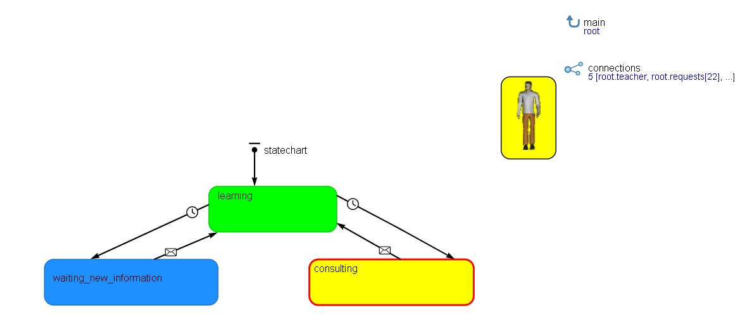
Fig. 2. The result of the implementation of the agent-based learning model (stage 1). Student agents are awaiting a response from a teacher-agent or are in a state of learning. It has shown with different colors (result of modelling in the AnyLogic system)

…
$$E_{i}=1−$$ | (1)
The result of constructing the first version of the model was the ability to evaluate the effectiveness of the study of the material by an individual student i, calculated as:

- RESEARCH RESULTS

The first group of results of the experiments has shown in table 1. As a basis for comparison, we took the indicators that were obtained when teaching students the specialty "System Analysis and Management" at the Crimean Federal University in the study of the discipline "Object-oriented programming." Ten students study in the group of second year. The discipline divides into 5 thematic modules. In total, five credits of 36 hours allotted for studying the discipline - 180 hours.

Table 1. The results of experiments with the model for classical forms of learning
 | Basic variant | 1 experiment | 2 experiment | 3 experiment | 4 experiment
Input parameters
The number of contacts of one student among students | 0 | 0 | 0 | 0 | 5
Average material complexity factor | 0,5 | 0,5 | 0,8 | 0,5 | 0,5
Average student ability coefficient | 0,5 | 0,5 | 0,5 | 0,8 | 0,5
Output results
Total counseling time (h) | 36 | 38 | 43 | 40 | 32
Individual effectiveness | 0,85 | 0,88 | 0,76 | 0,84 | 0,83
Overall system performance | 0,8 | 0,76 | 0,68 | 0,73 | 0,85
.

- CONCLUSIONS

In the present work, we studied the problems of the effectiveness of modern higher education systems and the existing approaches to its assessment. We revealed that modern conditions dictate the mandatory use of information and communication technologies in the learning process of students. The system of higher education is complicated and requires the use of modeling tools that will allow you to evaluate the nonlinear effect of heterogeneous factors. This work presents the results of applying the agent approach to the study of the problems of evaluating the effectiveness of modern higher education systems…

V. PROSPECTS FOR FURTHER RESEARCH

A separate problem is the modeling of the behavior of system managers and staff, which provides the framework of distance learning systems, the rules of behavior of other participants, and the adaptation of the entire structure to dynamic changes. Probably, for computer modeling of these processes, it is necessary to create simulation models in which, in addition to the agent approach, discrete-event and system-dynamic approaches are also used...

REFERENCES

[1] А. В. Дудатьєв, Комплексна інформаційна безпека соціотехнічних систем: моделі впливу та захисту. Вінниця, Україна: ВНТУ, 2017.
[2] W.-K. Chen, Linear Networks and Systems. Belmont, CA: Wadsworth, 1993, pp. 123-135.
[3] С. І. Перевозніков, Н. О. Біліченко, та В. С. Озеранський, Теорія інформації та кодування. Вінниця, Україна: ВНТУ, 2017.
[4] U. J. Gelinas, Jr., S. G. Sutton, and J. Fedorowicz, Business Processes and Information Technology. Cincinnati, USA: South-Western/Thomson Learning, 2004.
[5] В. Г. Петрук, В. А. Іщенко, І. В. Васильківський, Р. В. Петрук, П. М. Турчик, та С. М. Кватернюк, Дипломне проектування (для студентів екологічних спеціальностей). Вінниця, Україна: ВНТУ, 2017.
[6] О.М. Яхно, Ред., Прикладна гідроаеромеханіка і механотроніка. Вінниця, Україна: ВНТУ, 2017, 711 с.
[7] D. Sarunyagate, Ed., Lasers. New York: McGraw-Hill, 1996.

